**DESIGN PRINCIPLES AND CONTEXT**

**Sean Smart 1602648**

**STORYBOARDS** 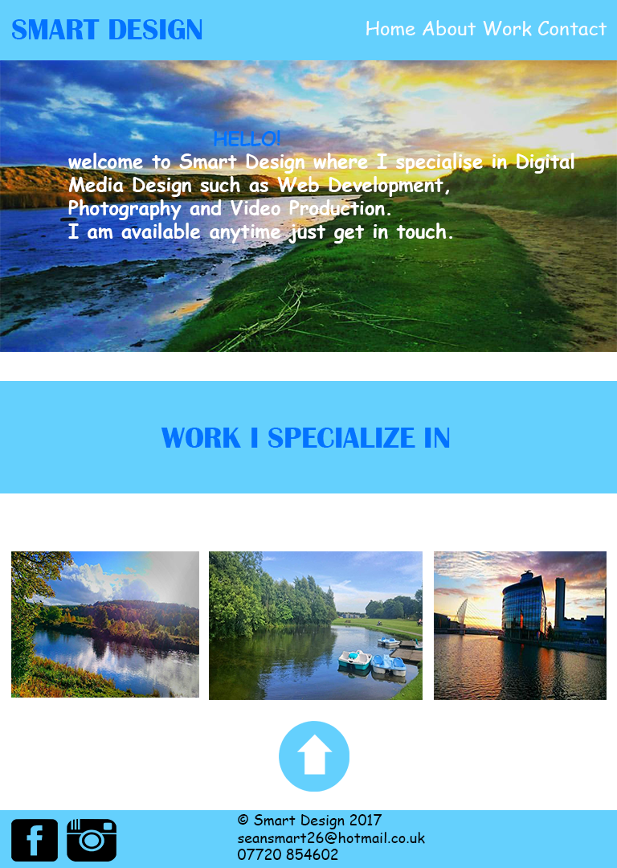

For the homepage design in my final portfolio design is taken from the vibrant colours because dark colours feel flat in this design the dark, the page will start off once finished loading the top image will slide down with the help of jQuery with the text a little about myself and what I do in my portfolio website, the three images will be clickable and will allow me to go straight to my works page with all of my portfolio work (I removed 2D animation because I am not that confident with it) the work page will contain work in Web Development, Photography and Video production, the three images will have a hover effect when you place your cursor on any of the three pictures, the arrow at the bottom is clickable and will take you back to the top of the webpage to reduce scrolling time and thanks to jQuery I made the scrolling smooth so it is comforting for the user’s experience, the footer has all of my contact details detail’s if you need to get in touch, there are two social media icons which you can click on which will take you to the link of your chosen social media (the navigation bar is fixed and will follow you while you scroll down the webpage.

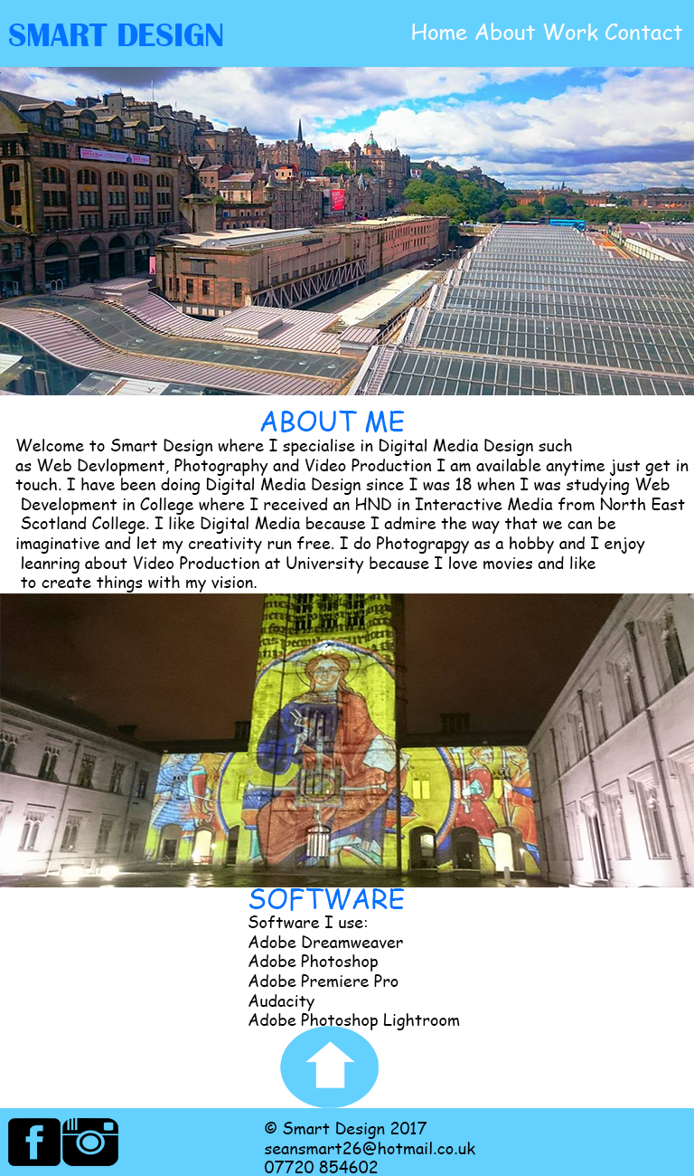

The about page has a longer description of who I am and a little backstory of how Smart Design came to be, the navigation bar is fixed and will follow you down the page while you scroll, the top image will slide down with the use of jQuery, while you scroll down there will be text to read, once you reach the bottom of the page, there is a list of software that I use while I create my products with, the blue arrow takes you back to the top of the page but smoothly with the use of jQuery while the footer has all of my contact details if you want to get in touch. With the clickable social media icons as well. The Smart Design logo is clickable and can take you back to the homepage of my portfolio website.

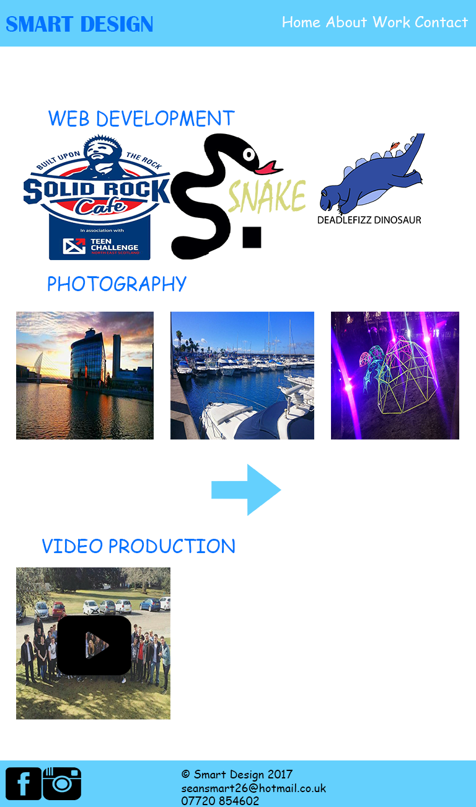

The work page is my portfolio of all the work that have done in the past including Web Development, Photography (the little blue arrow above is clickable and will take you to a new page with more images and Video Production which you can watch in your spare time all the images appear in a fade in jQuery language so the page doesn’t look flat or boring to look at, the navigation bar at the top follows you will you scroll down to reduce scrolling back up, and the footer has all of my contact details and social media pages to keep up to date with all of my latest projects. The Smart Design logo is clickable and can take you back to the homepage of my portfolio website.

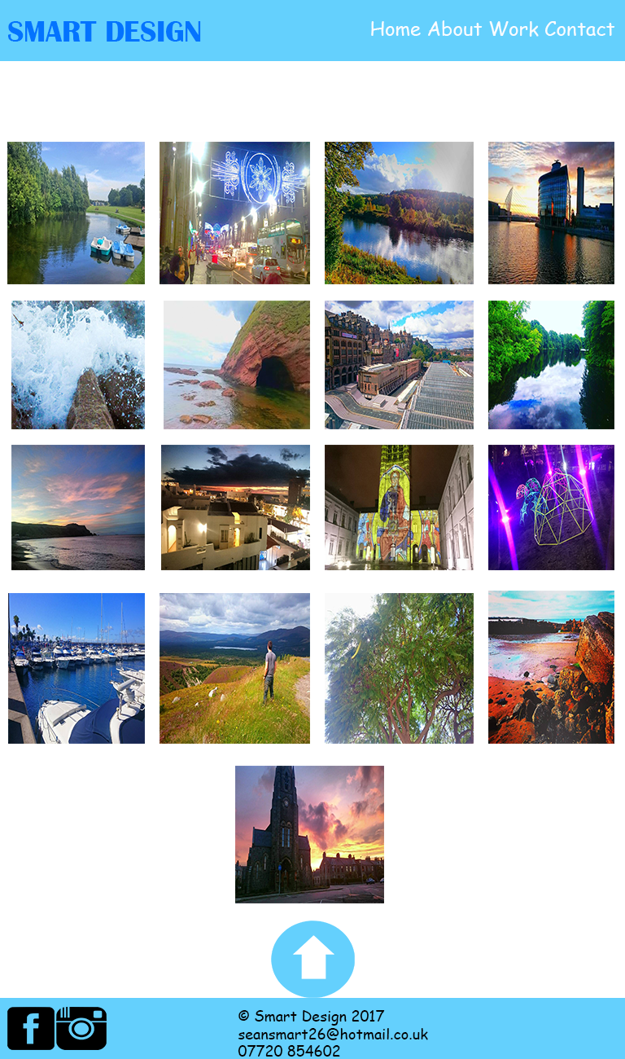

The photo gallery image contains more images for you to browse the images will fade in once the page has loaded by jQuery the images are clickable and once you click on your chosen image the image appears larger and an overlay covers the webpage the large image contains two arrows where you can go to the next image or previous image, you can close the overlay and enlarged image on the cross at the top right corner of the monitor. The image gallery was done entirely in JavaScript, the blue arrow once clicked on at the bottom of the page will take yourself back to the top of the webpage to reduce the time of having to scroll of the way back up again, the navigation bar will follow you since the position is fixed since if you want to go onto another page and not having to scroll back up to the top which takes time, the footer contains all of my contact details if you want to get in touch there is also my social media icons which you can click on and will navigate you to your chosen social media website.

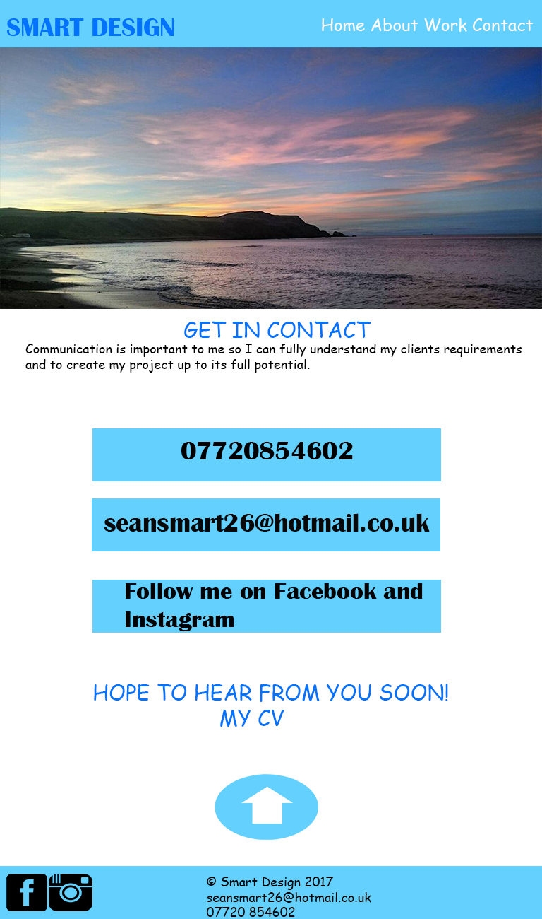

Now finally the contact page has the details if you want to get in touch, the image at the top of the page will slide down with the use of jQuery, while you scroll down the three rectangles will fade in together and will contain information on how you can get in touch with me if you are interested in one of my projects or if you are a potential client, there is a link to a PDF document to my CV once you click on my CV or if you have a hover it has a white underline so you will know that it is clickable, the blue arrow below will take you back to the top of the webpage smoothly thanks to jQuery and also reduces the scrolling time, the navigation bar remains fixed and will follow along with you while you continue to scroll down the page. The footer contains all my contact details and which social media that I use for Smart Design.

**References**

The Facebook, Instagram and Arrows used in my portfolio website belongs to <http://www.iconsdb.com/> where the icons are free to use which is handy because it takes up less time having to design the icons on my own.

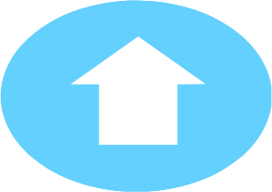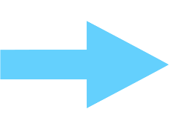

The images which I have chosen are actually my own which I have taken in my own spare time

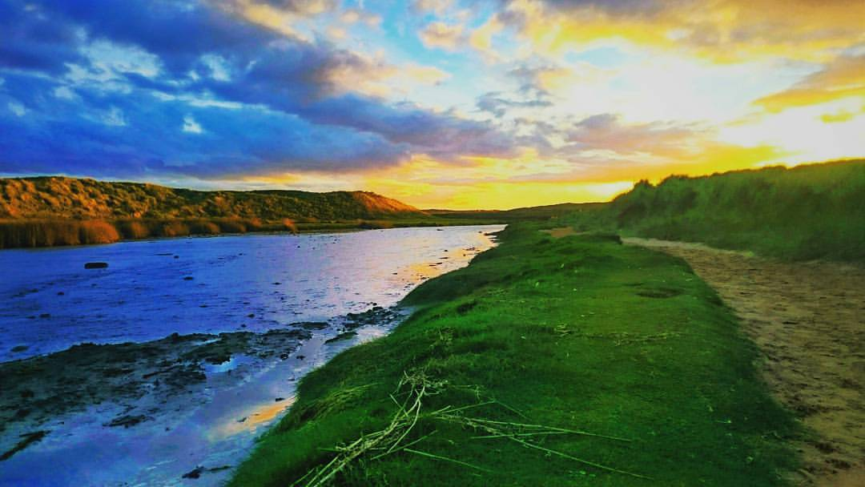

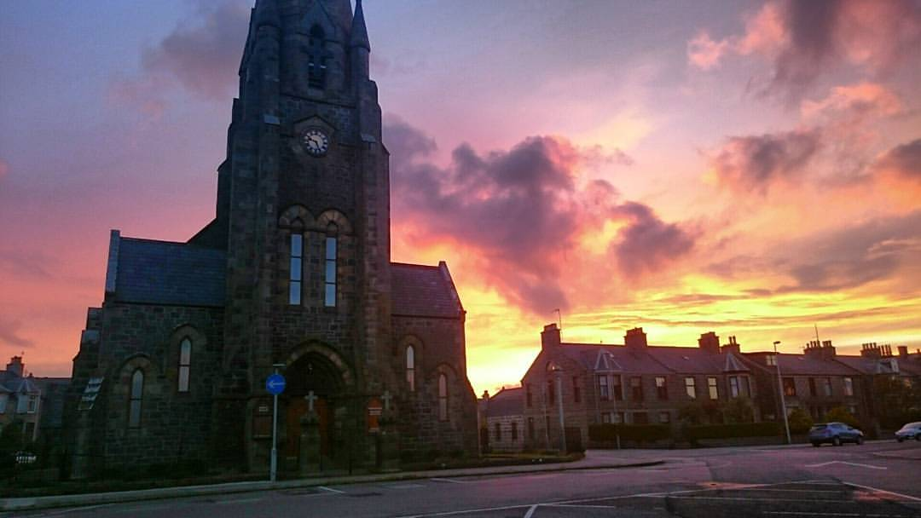

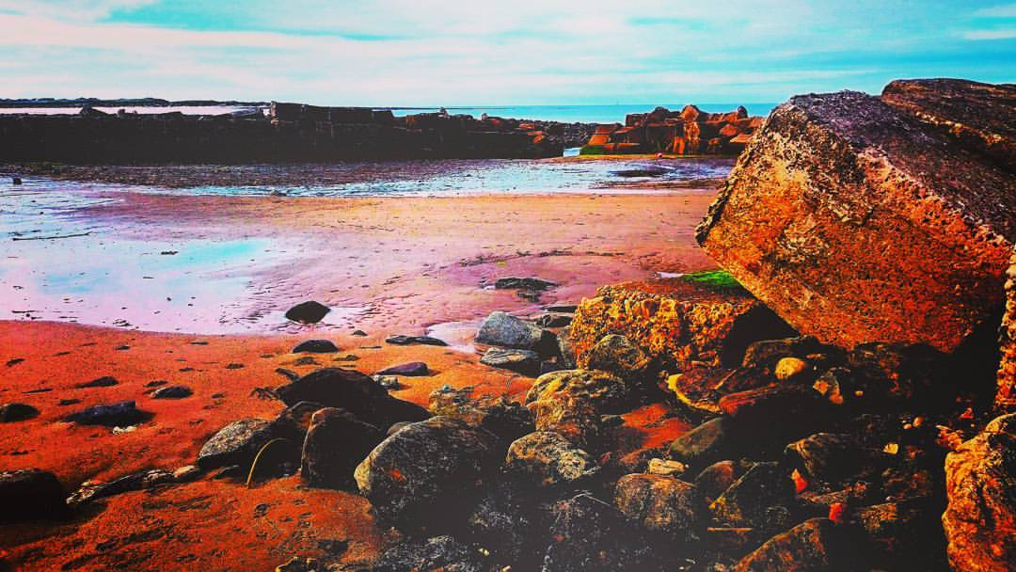

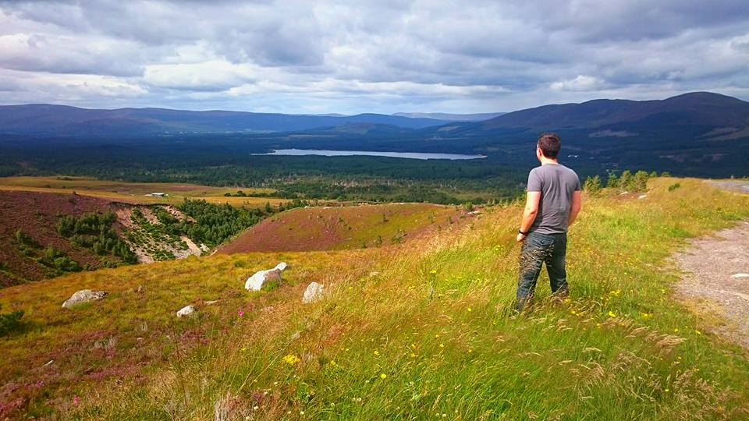

I have designed the logo on Photoshop as just the title of my Portfolio website. Because I didn’t want anything flashy and all in your face if the user can easily read the logo and know who I am



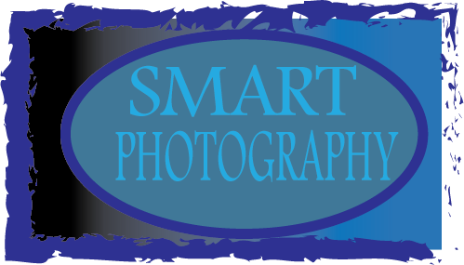

This logo didn’t work so well on any of my designs because it looked like it was just pasted on and looked amateur like, the top logo is much cleaner and nice to look at when the user is browsing the website for the first time.

**INFLUENCES**

[**http://www.herokidstudio.es/**](http://www.herokidstudio.es/)

[**http://patchworkarchitecture.co.nz/**](http://patchworkarchitecture.co.nz/)

[**http://markhobbsdesign.com/**](http://markhobbsdesign.com/)

[**https://justcoded.com/?utm_source=awwwards&utm_medium=banner&utm_content=10years**](https://justcoded.com/?utm_source=awwwards&utm_medium=banner&utm_content=10years)

[**http://www.size.agency/**](http://www.size.agency/)

The following links are my influences and inspirations for creating my portfolio website, there is a lot of style in these websites which have plenty of content and many methods for interacting with. You can browse through something happens like a fun little animation done in a language either jQuery or JavaScript I did not copy their style I just used these websites as a stepping guide of how to start off building my website

I decide a light blue colour for my website because it is nice and is quite pleasant to look at when you first open up the webpage blue symbolises calmness, peace and relaxing tone for a user which is a nice association to colour, I feel the font style Verdana works well because it is readable and the text is large enough to read so for accessibility reasons the website is good for use and fit for a purpose, the layout is simple and anyone will be able to access this website navigate through and click on whatever is clickable so the user can have a n interactive experience while exploring the features of my portfolio website.